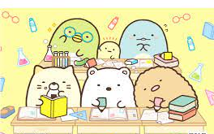
Big English 2 – Unit 1
- Vocabulary
- Gerunds (Verb+ing)
cut  cutting | read  reading | glue  gluing | color  coloring | play  playing | listen to  listening
wave  waving | count  counting | talk about  talking about | use  using | write  writing | say  saying

- Numbers
one | six | eleven | sixteen | plus
two | seven | twelve | seventeen | minus
three | eight | thirteen | eighteen | equals
four | nine | fourteen | nineteen | *thirty  forty  fifty  sixty  seventy  eighty  ninety  one hundred
five | ten | fifteen | twenty

- Country or city
England | Turkey | the United States | Vietnam
São Paulo | New York | Mexico | Hong Kong

- Grammar
- Present Progressive
What’s he / she doing? | He’s / She’s reading a book.
What are they doing? | They’re talking about the pictures.

Is he/she coloring a picture? | Yes, he / she is.  No, he / she isn’t. He / She is cutting paper.
Are they counting pencils? | Yes, they are.  No, they aren’t. They are gluing shapes.

- Usage Of How Many
How many pictures are there? | There’s one picture.
How many books are there? | There are three books.

